2012 – 2013 Powerline Hunt Club
Management Plan
Introduction
The Powerline Hunt Club (as we know it; with its current members) was established in 2005. It has grown to 1,619 acres as shown below in this aerial map. It consists of:
- 1,048 acres (blue) – leased from timber company
- 405 acres (red) – leased from a private land owner
- 60 acres (orange) – leased from a private land owner
- 105 acres (maroon) – leased from a private land owner
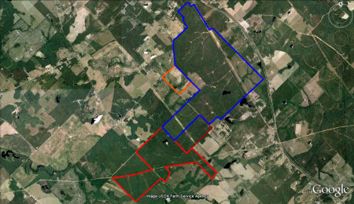
This plan was created to document and communicate with all the members the goals and plan of our 2012-2013 hunting season. This plan establishes actions and goals that can be measured at the end of the hunt season. The effective date of this plan is from January 16, 2012 – January 15, 2013.
NOTE: This is just a plan and changes will be made to this plan as the execution process occurs due to dynamic situations and budget limitations.
Goals
Powerline Hunt Club has been practicing quality deer management since its conception. Our philosophy is to let the young bucks walk, keep the doe to buck ratio as close to 1 to 1 as possible, and only shoot 3 ½ year or older bucks and/or minimum 4 points on one side and/or 15 inch outside spread.
Our club goals are as follows:
- Promote safety and hunter sportsmanship
- Improve deer and turkey habitat through supplement feed stations, mineral stations, and food plots
- Protect the young bucks that are 2 ½ years old and younger
- Increase the deer density per square mile
- Increase the deer’s body weight
- Increase the number of fawn productions
- Increase the turkey population
- Reduce predators
- Increase the age structures among the bucks
- Introduce young and non hunters to the hunting sport
- Have good positive hunting experiences
- Have a good time fellowshipping between the members
Some of Past Success Stories
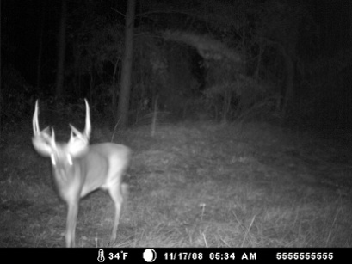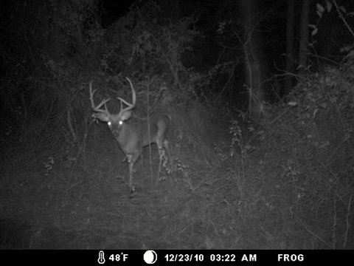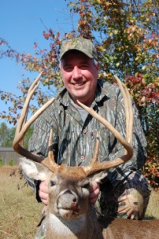
A legendary buck we called 911 was killed this season. He was a 5 ½ years old buck that all of us have been hunting the last 4 years. He scored 143” B/C gross score.
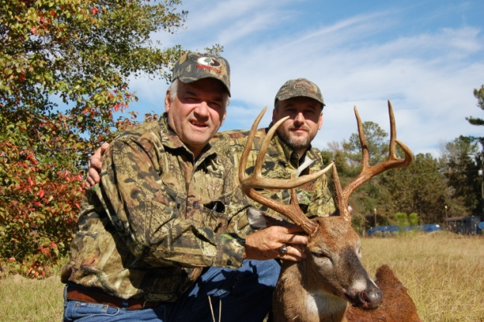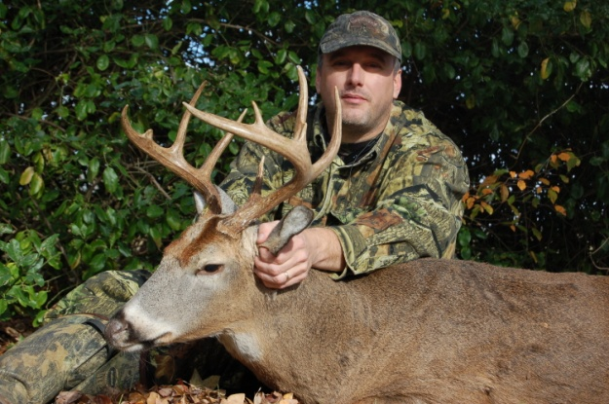
Another buck we have been watching a few years went down this season. This buck we called Sway and he was a 4 ½ year old buck. Another buck we killed this year we named the Blurr Buck due to all the photos we got of him on trail cameras was always blurred. We estimate him to be a 4 ½ year old also.
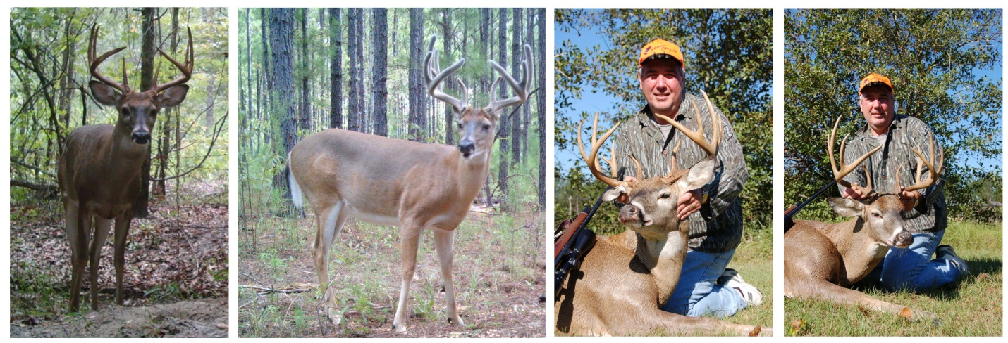
This is an 8 pointer we killed on club during a past season named “V”. Far left picture is this deer during the 2008-2009 season. The next picture is him during August in 2009 – 2010 season. The two pictures to the right are of the deer killed in 2009-2010 season. This deer was a 4 ½ year old and a gross 143” gross B/C score.
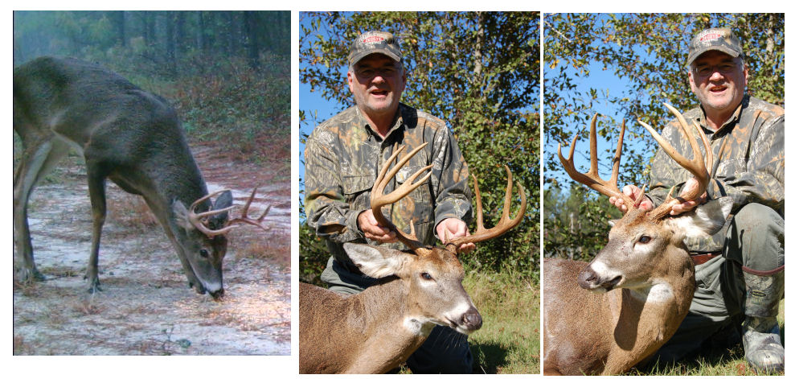
This is a 9 pointer killed on club during the 2009 – 2010 season. The picture on the far left is this deer during the 2008-2009 season as a 2 ½ and the two pictures to the right are of the deer killed in 2009-2010 season at 3 ½.
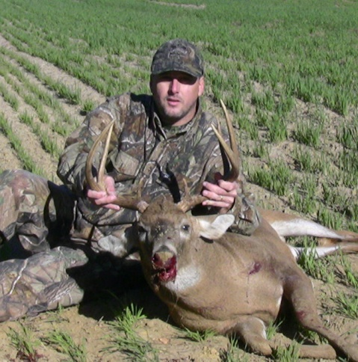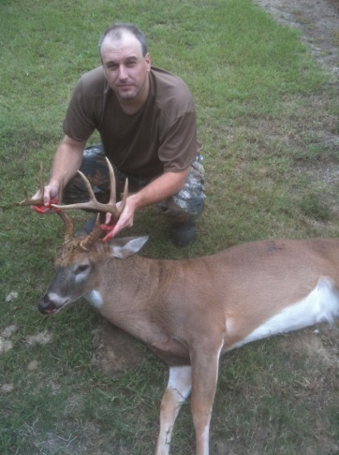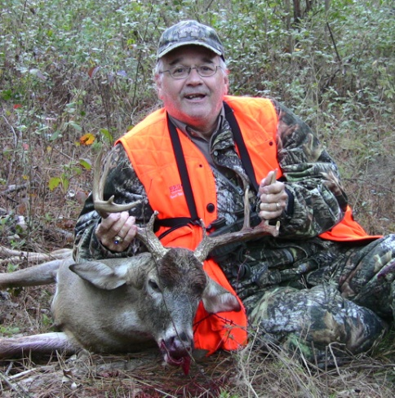
Three 4 ½ year old bucks killed during the 2010-2011 season.
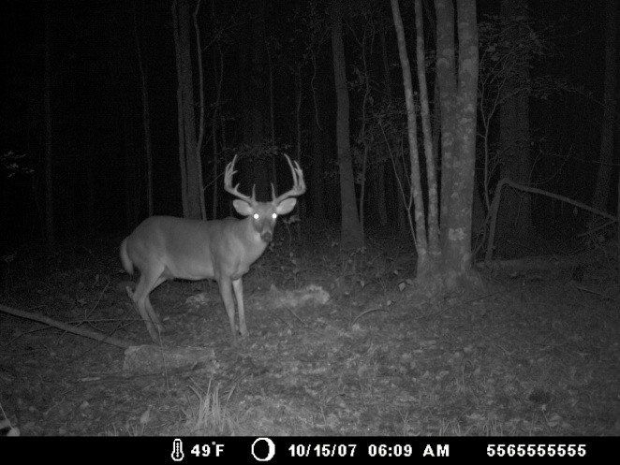 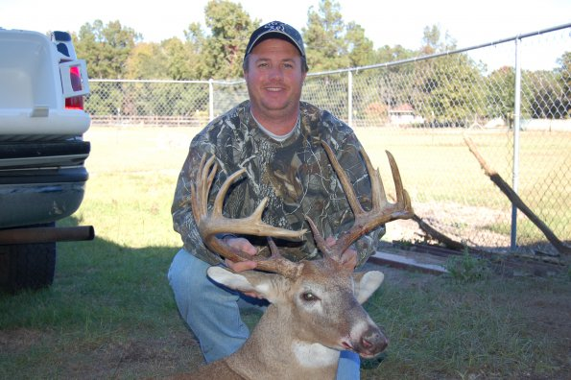
This is the biggest deer ever killed on the club during the 2007-2008 season measured 163” gross B/C.
Facts from the 2011-2012 Season:
- Number deer harvested: 6 bucks, 12 does
- Predators: 7 grey foxes, 2 bobcats, 2 raccoons, 1 coyote
- These are photos of deer we think that made it through the season. We will not know for sure until we start monitoring trail cameras in May.
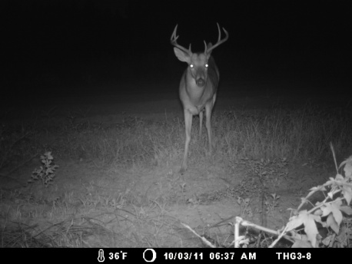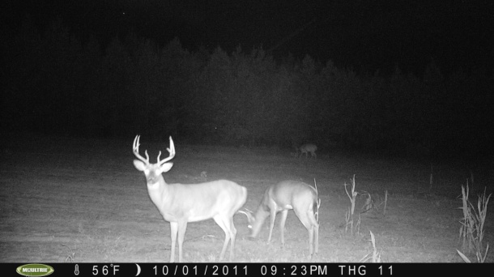
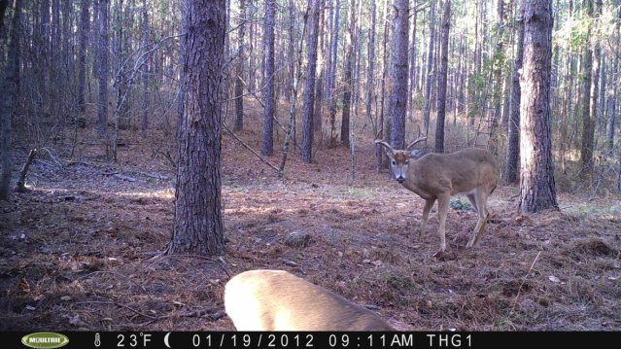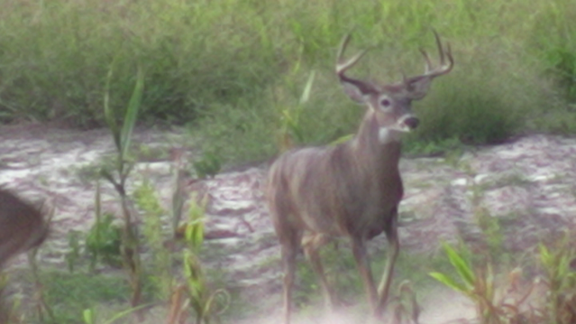
Supplement Feeding Plan
Our club has built 2 on demand nudge feeders to use this season. These feeders are shown below.
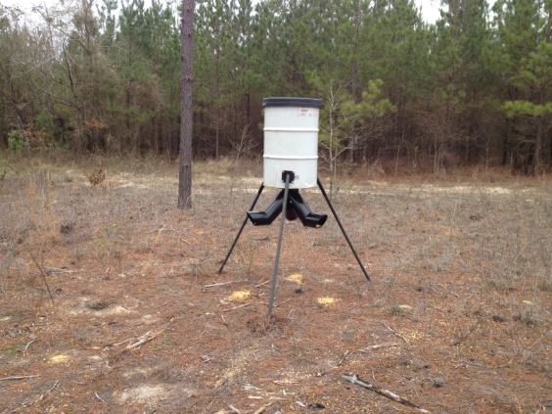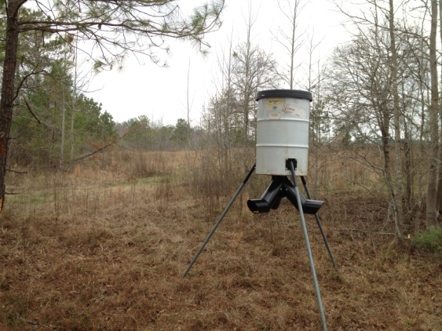
We put the feeders out in February with corn and once we feel that enough deer are eating from them then we will switch to a high protein feed. There is a possibility that this might not occur until next year therefore we are going to keep using corn until then due to the lower price per pound. We located both these supplement feeders around the fields where we going to plant peanuts, soybeans, and grain sorghum (See the planting plan section below).
This plan is also proposing 12 feed stations during the hunting season. These feed stations will consist primarily of electronic timed spinner feeders and will be put out and filled with corn a few weeks before deer season begins. Some will be used earlier for bow season and the rest during gun season. The purposes of the feeders are to spread corn every day at a set time so to attract and retain the deer. These feeders will be hunted over since baiting was made legal in the south zone in Georgia in 2011.
These 2 on demand feeders and 12 spinner feeds are shown below in general. These locations are subject to change as required.
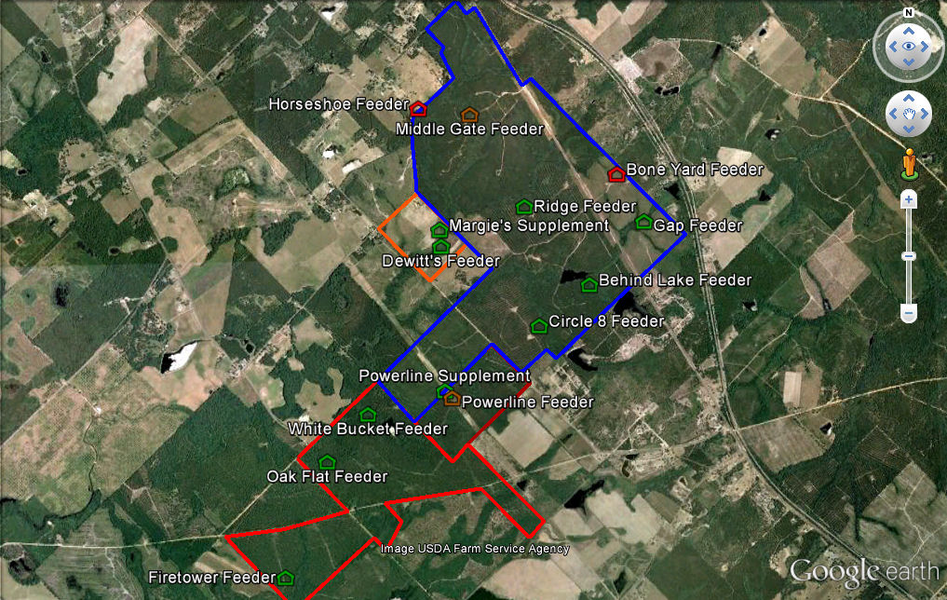
Mineral Supplements
Mineral supplements have been proven to help with antler growth in bucks, doe milk production increases, and general supplement of minerals deer are lacking in their diet. The club plans to put out generic Trophy Rock equivalent blocks at various locations on the club where deer like to frequent during the summer months.
Planting Plan
The club currently has a variety of different food plots (approximately 32 total) scattered around the club. The club plans to plant two times during the year. These plan times are as follows:
- April 15th – Spring/Summer
- October 1st – Fall/Winter
April 15th – Spring/Summer
The plan is to plant 20 acres of peanuts, 7 acres of soybeans, and 5 acres of grain sorghum (Milo). Deer will eat the peanuts and soybean as the green up and grow leaves and we plan to leave the soybeans standing with beans once the leaves fall off. The peanuts will be harvested September 1st by the farmer who is paying to plant them but we plan on leaving a few strips of turned peanuts for the deer to consume. This will provide an excellent attractive for deer season and the standing soybeans will provide great food for the deer during the winter. We are also going to plant grain sorghum as a privacy fence around the soybeans in order to give the deer and turkeys additional security when feeding during daylight hours. These areas are shown below in the aerial photos:
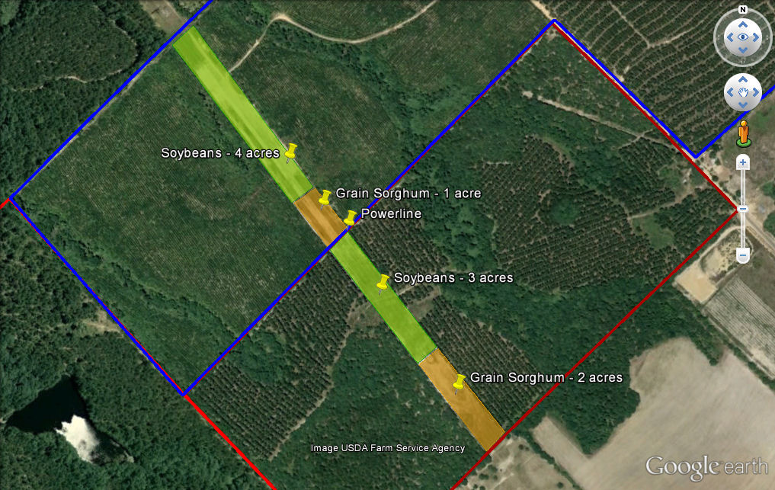Powerline – 10 acres
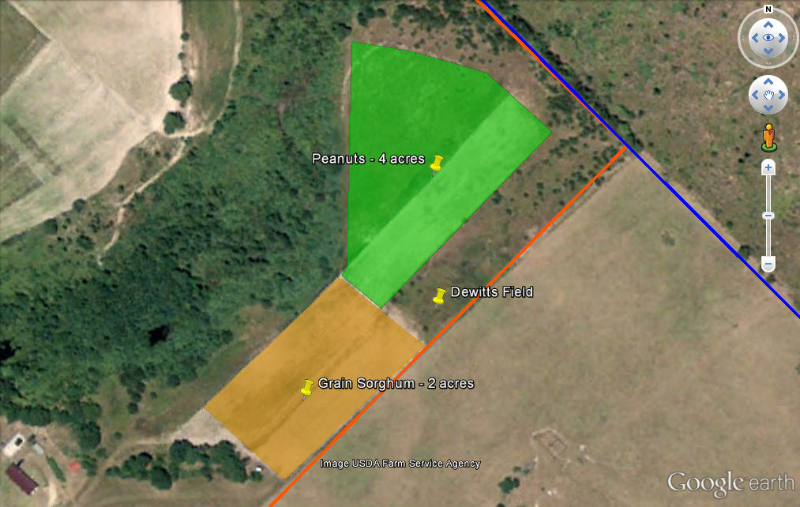Dewitt’s – 7 acres
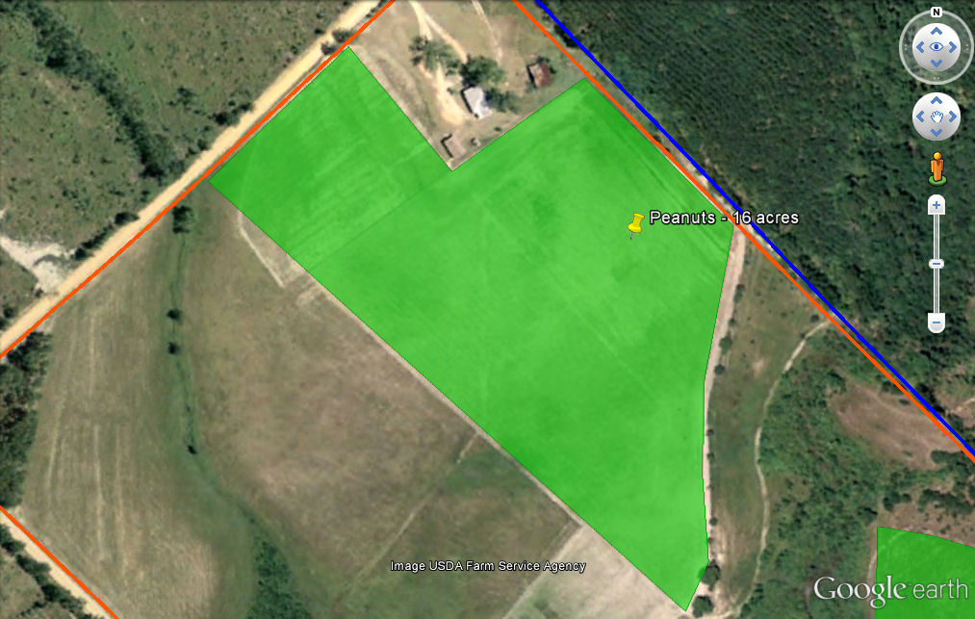Margie’s – 16 acres
Note: We plan to put an electric fence around the 7 acres of soybeans on the Powerline.
October 1st – Fall/Winter
The plan is to plant 4 acres of oats for the fall/winter. All of the road bed food plots will be planted as listed below plus strips will be inserted into the earlier planted soybeans and grain sorghum for some additional attractant. These food plots are shown below in an overall aerial view.
1. Y – 1/4 acre
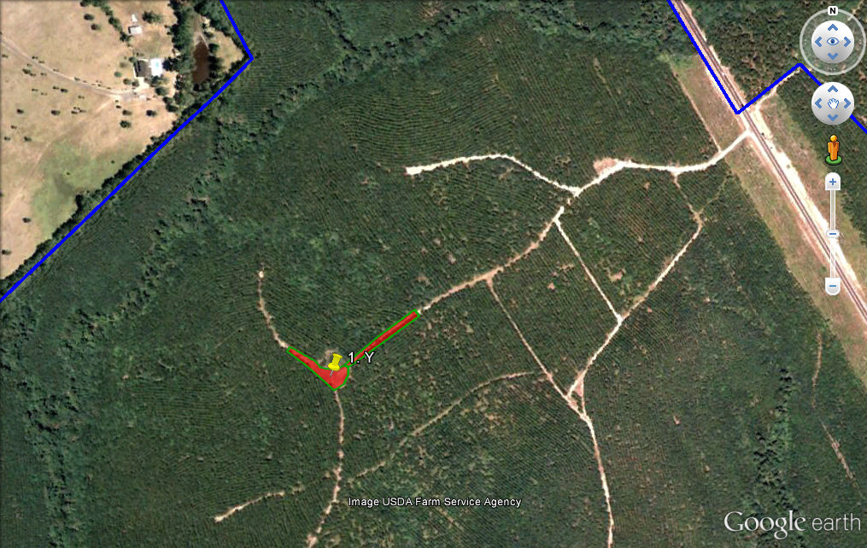
2. South Box – 1/8 acre
3. Bone Yard – 1/8 acre
4. Ridge Tower (New) – 1/8 acre
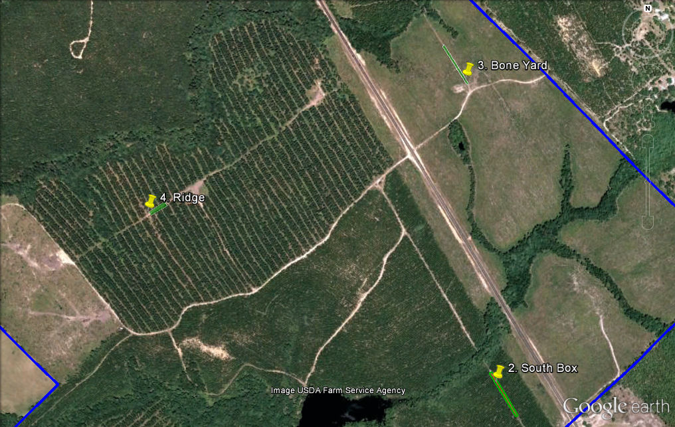
5. Circle 8 – Plot A – 1/3 acre
6. Cube – 1/8 acre
7. White Bucket – 1/2 acre
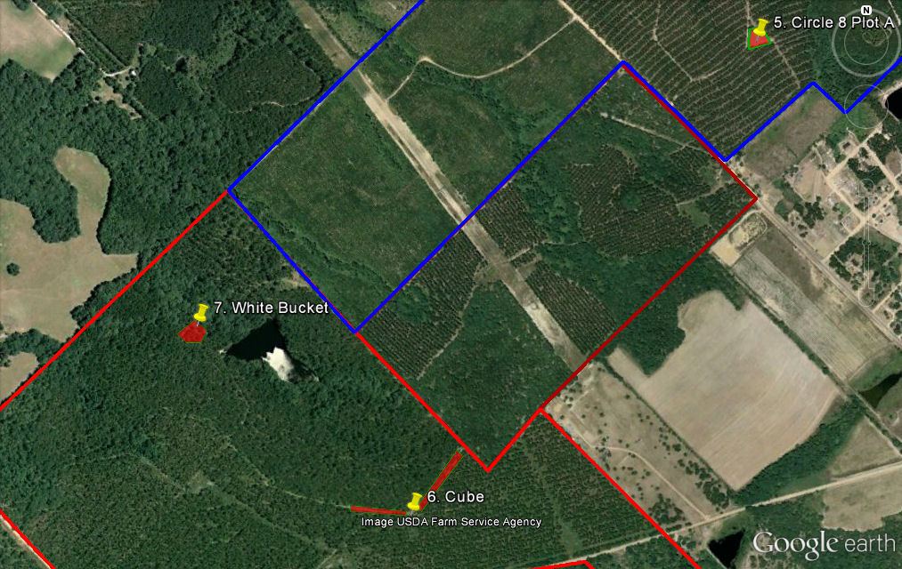
8. Cross – 1/3 acre
9. Firetower – 1/3 acre
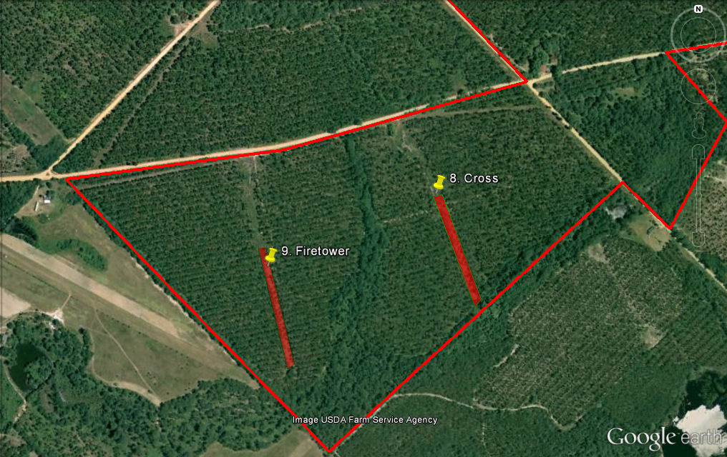
Powerline - Strip in strips within the soybeans
Dewitt’s Field – Strip in strips within the grain sorghum
Margies – Strip in strips within the left over peanuts
Overall Total for 2012-2013: 36 acres
Predator Management
We started a predator management program last year. We can shoot most predators up to February 28th. We have been focusing on hunting and trapping raccoons, foxes, bobcats, and coyotes.
Our main reasons for predator management:
- Protect our turkey eggs and pouts
- Fawn recruitment
- Keep our feeders from being tore up
- Keep predators from consuming our corn at our feed stations
For the past 2 years our harvest records are:
Raccoons: 19
Grey Foxes: 10
Bobcats: 3
Coyotes: 1
Measurements and Metrics
With any good plan there have to be a way to measure its success. This is important for planning the next plan for the following hunting season. The following ways will be used to measure this plan:
- Harvest records – How many bucks? How many does? What were their weights? What were their B & C scores?
- Observation – How many and what sex deer members are reporting they see during the season.
- Trail Camera photos during the season
- Trail Camera surveys at the beginning and the end of the season to calculate the deer density and the buck to doe ratios.
- General surveys from the members as to what their opinions as to the effectiveness of this plan in comparison to the season they just completed.
Conclusions
This plan is an effort to organize the Powerline Hunt Club hunting strategy and quality deer management practices. It outlines what we consider a successful plan and if the weather permits and enough time and money are put into it then the 2012 – 2013 will be a productive year. Then hopefully we will produce more deer like the ones below. Note: All these deer pictures were taken on the current club over the past 7 seasons.
